ARDUINO TRAFFIC LIGHT

A simple step-by-step tutorial for a beginner Arduino project!

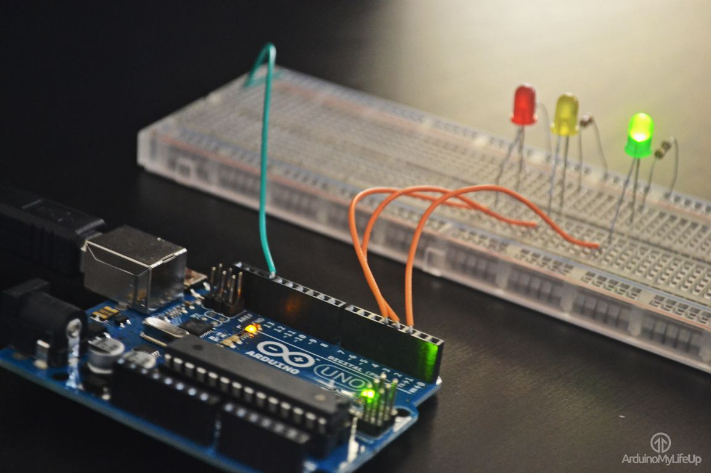

**Latiff Parkinson**

**Larbi Ernst**

**Janet Voong**

**Shange Fagan**

# INTRODUCTION - OUTLINE

For this topic we were tasked with utilising our abilities, after studying the various aspects of project management used in business and industrial environments/projects, so that we may conceptualise a product whilst working cohesively. Although it was not mandatory, our group used an Arduino motherboard to create our computer system: initially the team had brainstormed several ideas and various concepts that may or may not have worked, and after much deliberation, we came to the conclusion that the traffic light system would be the most practical application of our resources.

# INTRODUCTION - OUR TEAM

For our project, we assigned different roles to each member of our team, based on our skills, in order to produce the optimum end result. Janet was assigned the role of project manager due to her ability to effectively communicate with each member of the team and delegate tasks. Larbi was allocated the position to manage the software as he has advanced skills in coding. Latiff and Shange were responsible for the hardware since they had the best understanding of the various types of hardware we used for the project.

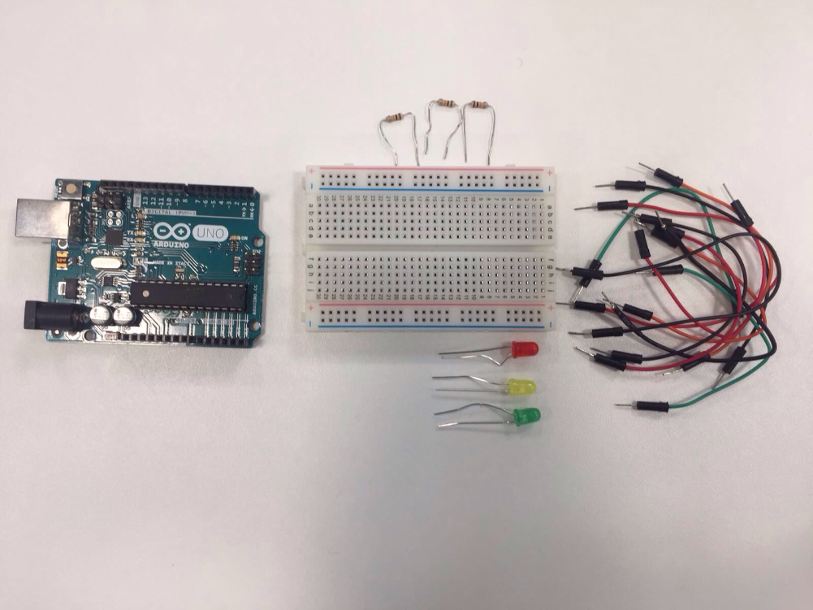

# RESOURCES

Aside from the basic Arduino, we needed:

* Red, yellow and green LEDs - You can find a batch of 20 on eBay for £1.47.
* We required this to simulate real traffic lights on the breadboard.
* A breadboard - £10 in most places.
* When using an Arduino, a breadboard is usually vital as it provides a means for the hardware involved to be run by the software. It allows us to visualise the code.
* 3 x 10k resistors - 20p per resistor in most online stores.
* We do not fundamentally need resistors, but they were a safeguard in case there was a surge of electricity in either of the LEDs. The resistors would absorb this excess energy and prevent the light emitting diodes from blowing or ‘short-circuiting.’
* Connecting wires - £2.24 for 10 male to male jumper-wires online.
* We needed jump wires to connect the Arduino board to the LEDs on the breadboard.
* 1 x Arduino board - £20.
* We needed this board to run and test our code on.
* Total price: £40.00.
* Our budget was £50, meaning we still had £10 buffer money remaining.

Our Budget and Resource Spreedsheet: <https://docs.google.com/spreadsheets/d/1ek-ZVsOo7kcD0NNdgt-jyloSvPvYqqvUVYs_kUNuhhg/edit#gid=0>

# PROCEDURE - WHAT IT SHOULD LOOK LIKE

# 

# 

# 

# PROCEDURE - THE CODE

Firstly, you need to define the variables so that you are able to address the traffic lights by a name rather than a number. Then open a new arduino project and begin with these lines.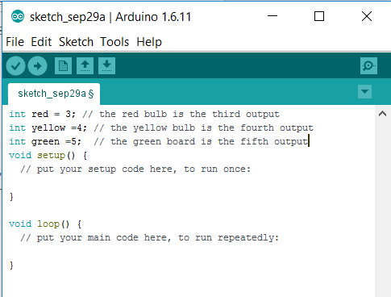

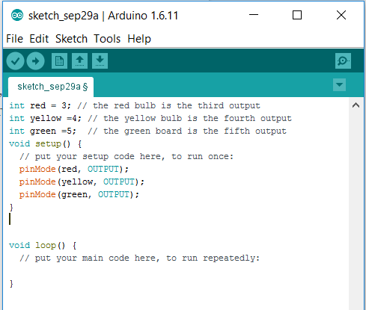

Next, you should insert the code to the setup function - this configures the red, yellow, and green LEDs as outputs. Since you have created variables to represent the pin numbers, you can now refer to the pins by their names instead.

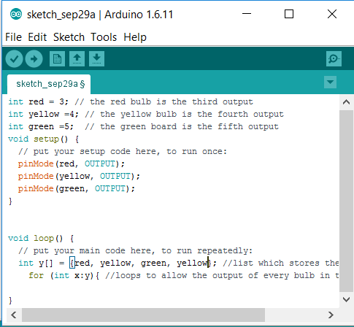

Then, inside the loop function, you would need to create lines to generate a list. Inside this list are the steps for changing the lights, this will loop out in order from beginning to end.

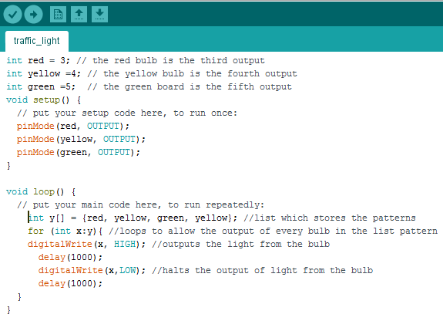

Finally, we create the lines that cause the light bulbs to light up and after a short delay turn off, this is the final code.

# HOW WE IMPROVED

We were able to refine our final product by simplifying the design, meaning that we reduced the amount of wires involved. This simplifies the structure of the traffic lights allowing further insight as to how it works, thus making it less messy and more presentable.

By doing so we were able to further understand how the product functions as well as better our knowledge on the Arduino.

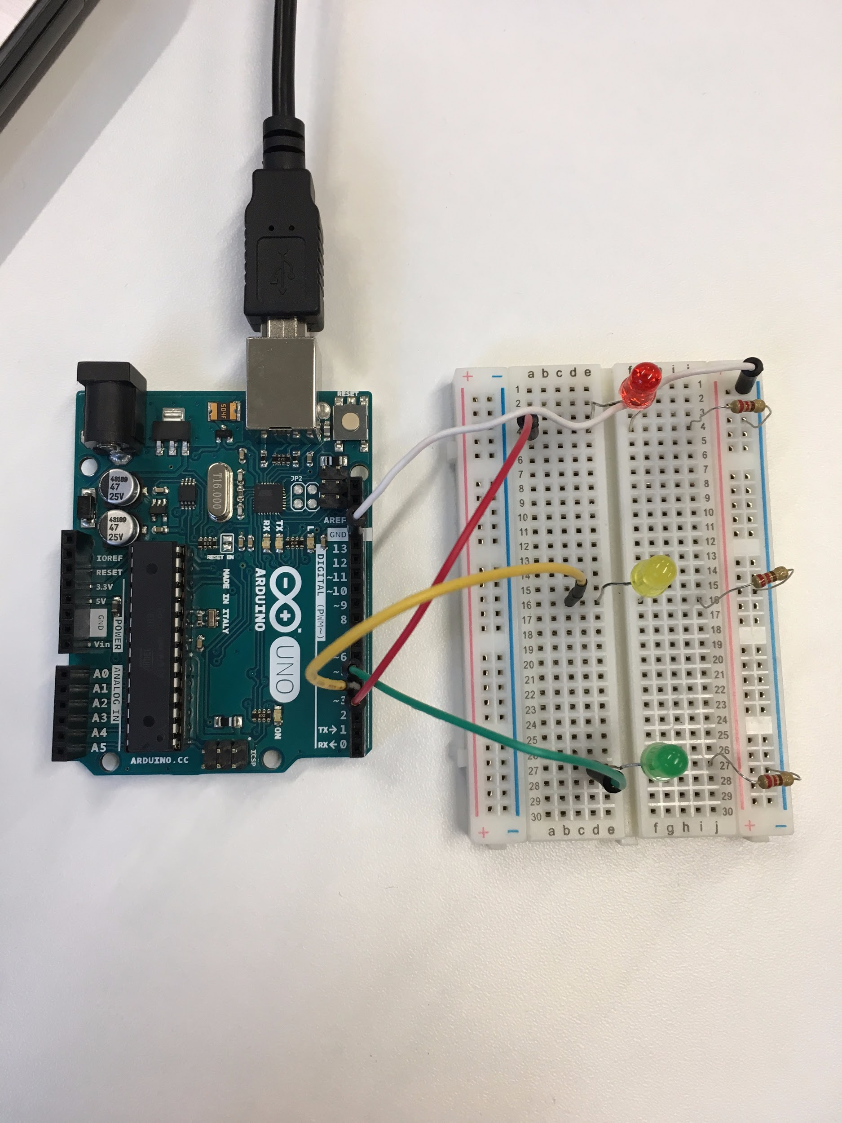

# 

# 

# 

# 

# 

# CONCLUSION

The end result of our work was a simplified model of the initial concept (being the traffic light structure). By using fewer hardware components and simplifying the code, the efficiency of the end result was significantly more impressive than that of what was ideated to begin with.

Furthermore, when using the items that we did our team incurred no additional costs and was not over budget by the end of the task, evidencing our use of bottom up budgeting wherein we incurred expenses whilst working, however within reason, meaning that no additional funds were spent when evaluating the total cost of the components after the project had come to an end.

Moreover we were able to efficiently manage our time by making appropriate use of a GANTT chart that enabled the team to successfully categorise the actions taken in the project and set aside a time for each of them. By doing so milestones and time constraints set by the team were easily met.

Ultimately our team was able to meet the criteria.

# REFERENCES

1. <http://www.makeuseof.com/tag/arduino-traffic-light-controller/>
2. Our GANTT Chart: <https://docs.google.com/spreadsheets/d/154vyko7LWB54fkKOy0hJioV74Q8KsQGBVJ6TX1cl_M4/edit>